**ASSIGNMENT DAY 10**

**On the basis of methods taught by sir till now and the methods sir discussed till day you have to get the analysis and form 10 hypothesis that could justify the attrition patterns in the company .  
Provide screenshot to support your hypothesis in a the file and submit it under the day 10 section**

1. Employee having an age below 35 years have lesser chance of Attrition.

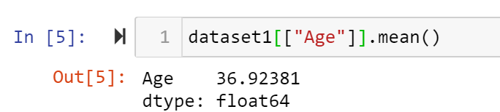

1. Employee whose Distance from Home is more than 15kms have greater chances of attrition.

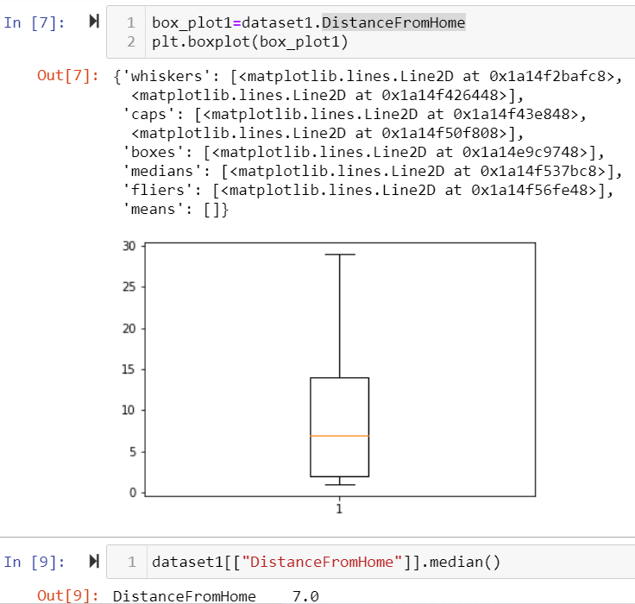

1. Variation in Standard working hours of an employee has no impact on attrition.

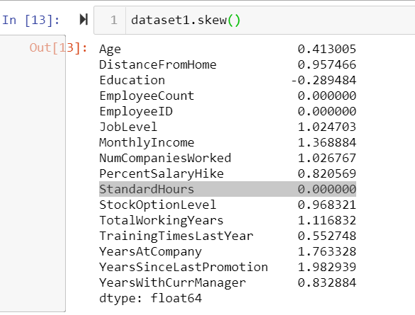

1. Employee having Education less than 3 have greater attrition in the company as it has negative skewness.

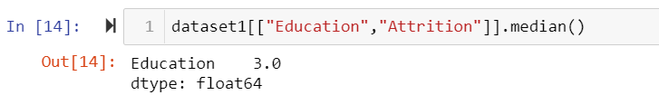



1. Employee with Job Level 1 in a company has less chances of survival.

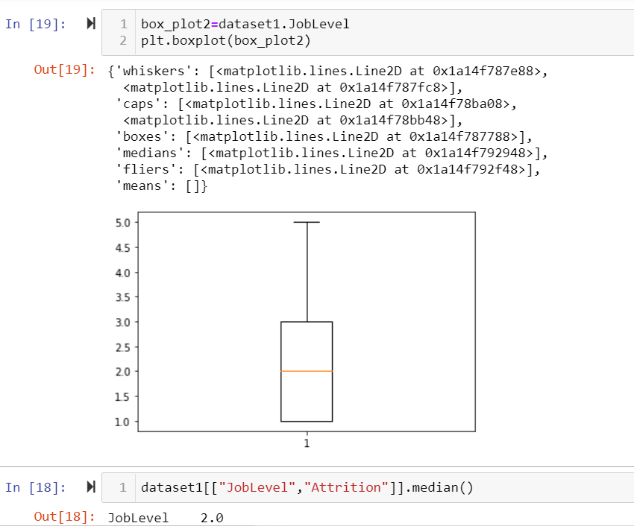

1. The average Salary of an employee in the company is 65000 per month.



1. The average number of companies that the employee has worked previously in a company is 2.

